|  |
| --- |
| <Sydney Airbnb> Executive Summary |
| Chelzie Castanares – s5259144, Thien Thao My Bui – s52737532810ICT Software Technologies8/010/23 |

# Abstract

A 100 to 150 word executive summary of your findings. Do this last.

# Introduction

Explains the purpose of this report. Include the date range covered, and the different analysis tasks performed

This report was conducted to develop a visualisation tool for the client Airbnb, by providing data analysis of properties within Sydney to help the business understand patterns and trends in order to grow and maximise profits. As a leading global hospitality business specialising in accommodation, many of Airbnb’s users are in need of finding the perfect accommodation within their budget and ideal location. Thus, a visualisation tool was created to help the users and Airbnb with concerns regarding accommodation. The data set that was given covered the date range from December 2018 – 2019 and displayed all active properties within Sydney. The goal of the visualisation tool were to form the following tasks:

* Within a user-selected period, return all the listings in a specified suburb.
* Within a user-selected period, display the distribution of prices of properties using a chart.
* Within a user-selected period, retrieve all records that contain a specific keyword (e.g., pool, 2-bedroom).
* Analyse the comments relating to cleanliness of the property such as (dust, dirt etc.).
* Return the average review score and variations of a user-selected property.

Based on the requirements of your dataset, put the results of your analysis of a 12 month date period for each of the required functionalities in these sections. Change the title names to reflect your dataset and the analysis being performed. You may include images from your program as well as your own description of the results.

# **Analysis 1 - Property Search <Report all listings in a specified suburb>**

The first analysis tackles the first task of the visualisation tool which is to return all properties within a selected suburb and a user-selected period. As shown in the image above, the entered period of time is 01/12/2019 – 06/12/2019 with the following specified suburbs being Balgowlah, North Sydney & Bondi Beach. The results of this search will then show all the available listings within these suburbs as provided in the next two images below.

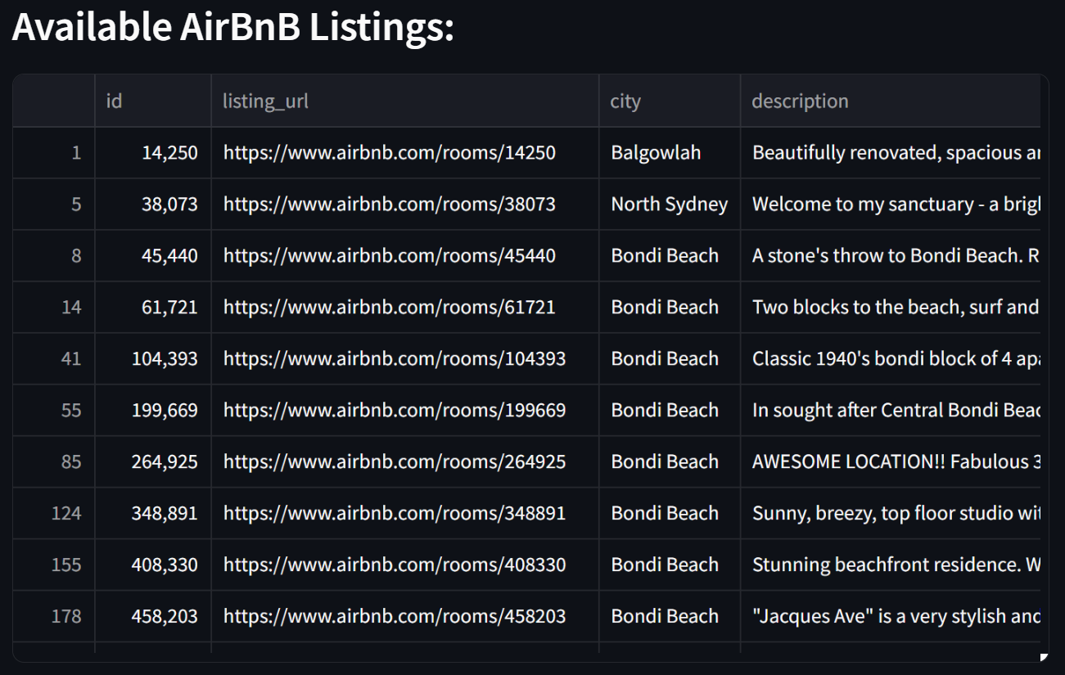

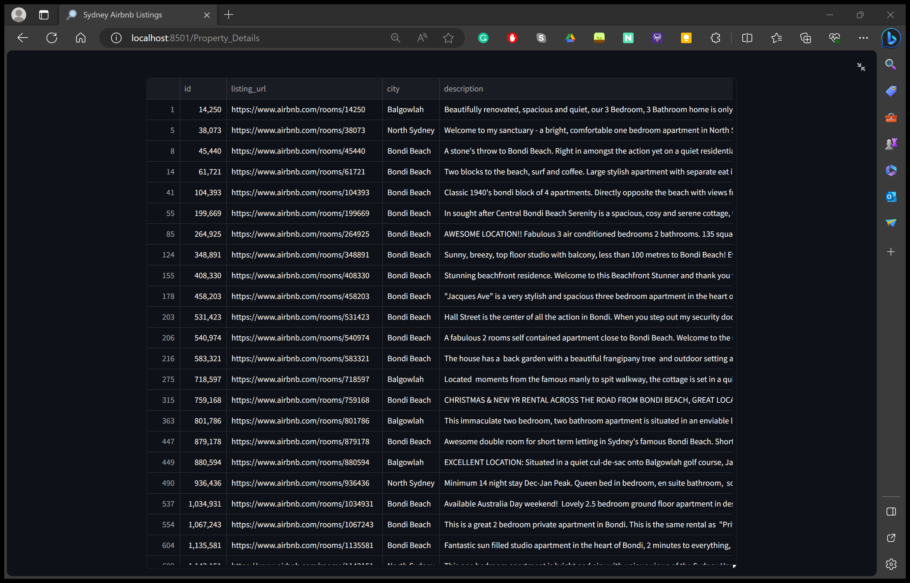

Therefore, the user is able to select either one or multiple suburbs depending on their preference and period of time and can click in the table to observe all the records. This is an essential functionality as it allows the users to be more efficient and target their ideal location of stay, making their holiday planning much easier.

# **Analysis 2 – Property Price Search <Displays distribution price of properties>**

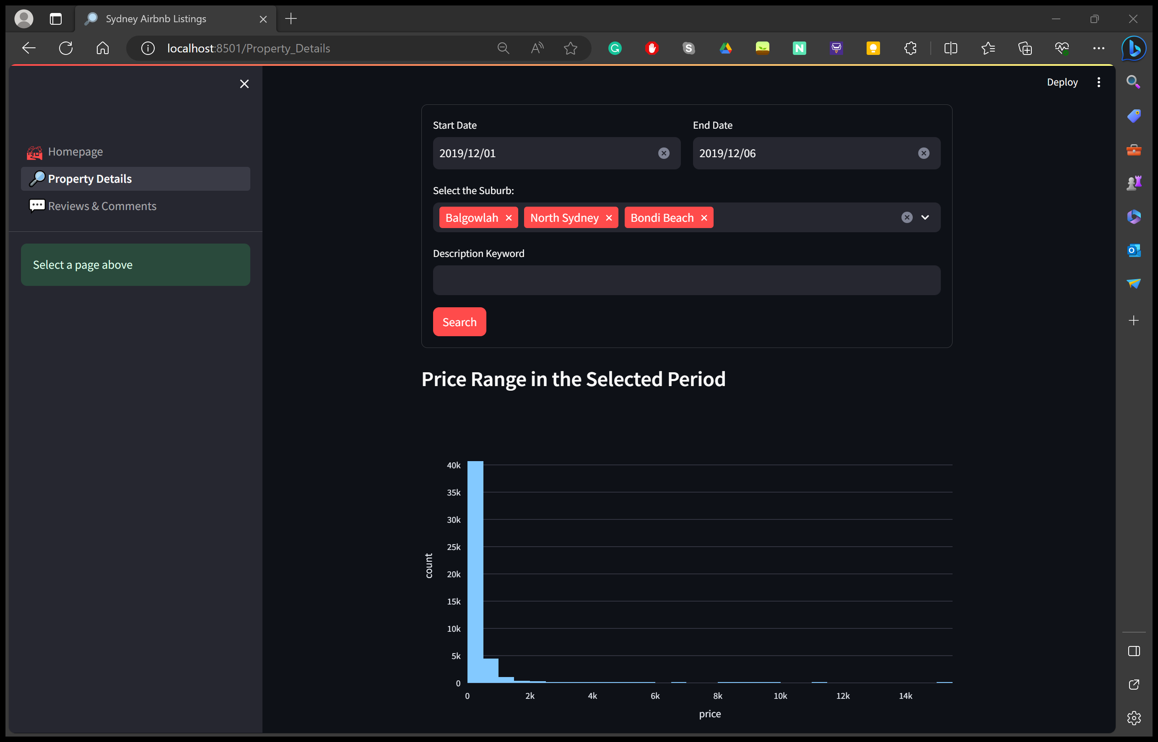

The second analysis focuses on the second task of the visualisation tool which is to display the prices of Airbnb properties within Sydney using a chart. The image above displays the prices of the properties in a bar chart between the user selected period: 1/12/2019 – 6/12/2019 and the following suburbs: Balgowlah, North Sydney & Bondi Beach. Based on the results, about 40,000 properties within those suburbs are below the price range of $1000, meaning that Airbnb properties within these regions are pretty affordable. This task plays a big role in a users’ decision of staying in an Airbnb as they can filter out areas that are out of their budget or find areas that are within their budget.

The bar chart is also able to be zoomed in to get a closer view on the figures as shown in the following image below.

# **Analysis 3 – Keyword Search <Return all properties with a specified keyword>**

The third analysis specialises in the third task of keyword searches, which is to return all record of properties that contain the specified keyword such as, 2 bedroom / pool / air-conditioning etc.

The following image above shows the scenario of a user entering the selected period: 1/12/2019 – 6/12/2019, the following suburbs: Balgowlah, North Sydney & Bondi Beach and the desired keyword: 2 bedrooms. The following image below will then display all records of properties that match the search.

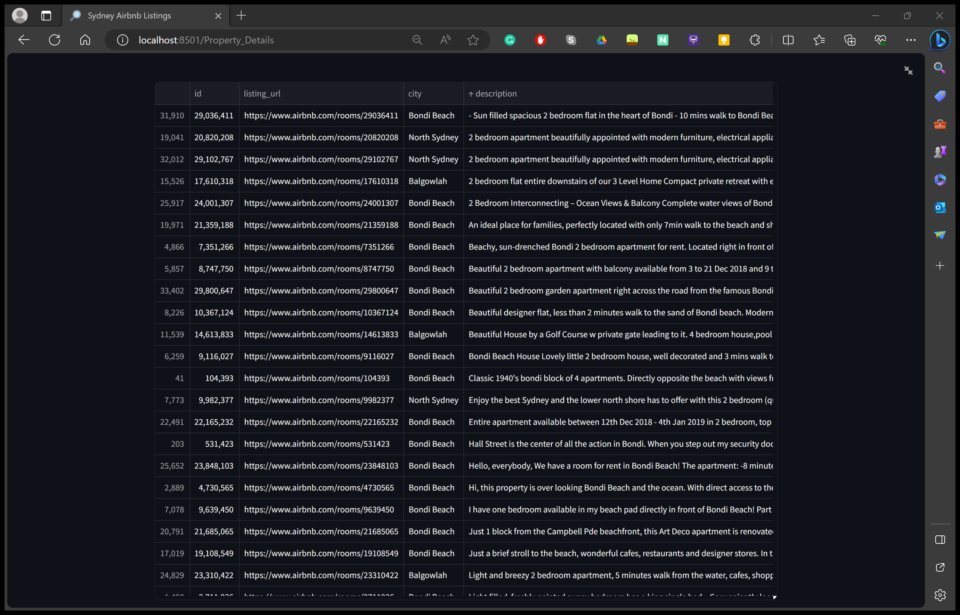

While the image above shows all the available properties with 2 bedrooms, if the user were to enter another keyword with it such as air-conditioning, the following results will be displayed in the image below.

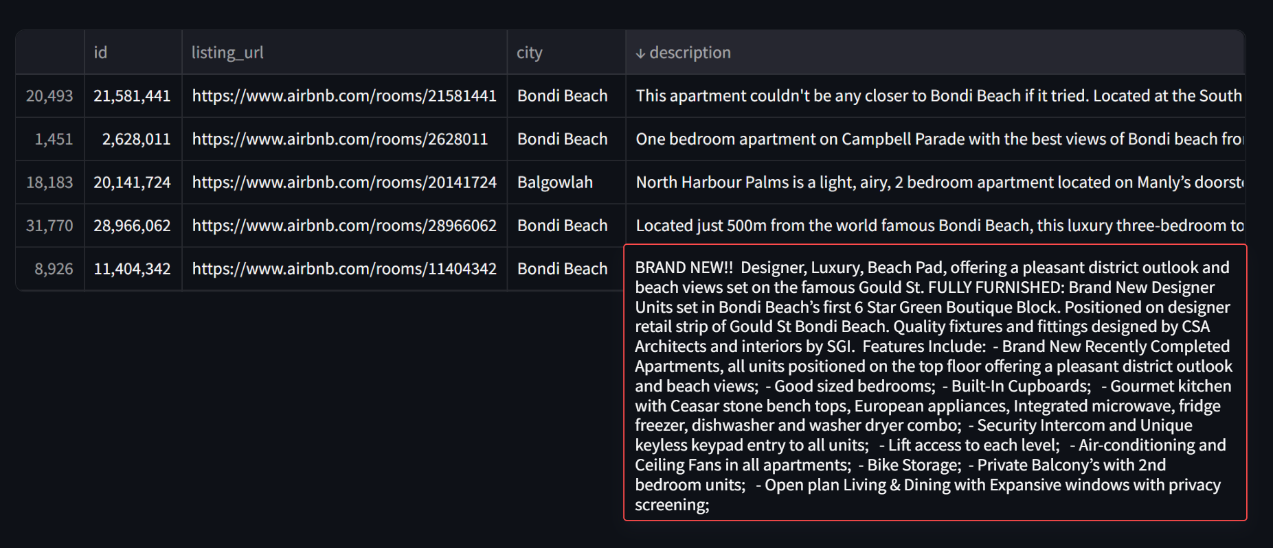

It can be observed from the image above that the number of available properties significantly drop after adding more keywords allowing the user to find properties that are more suited to their taste. This is a very efficient task as it gives users an opportunity to find properties that can accommodate to their needs such as pools, or more bedrooms for bigger families thus catering to the large target market of Airbnb.

# **Analysis 4 – Comments Search <Return all comments for a specified property>**

The fourth analysis relates to the fourth task which is to return all comments relating to the cleanliness of a specified property. As seen in the photos below, the user is able to input the property ID of the Airbnb that they wish to check for cleanliness. By inputting the ID, they are able to get all the comments that talk about the property’s cleanliness. This is useful for the users, as they are able to see which properties are clean and up to health standards as many customers could have dust allergies and require clean places to stay in.

Cleanliness Comments:

# **Analysis 5 – Review System <Return the review score of a specified property>**

The fifth analysis relates to the fifth task of the visualisation tool which is the review system and returns the average review score of a specified property along with some variations such as the property’s communication, location and value. As shown in the image below, a property is rated out of 5 stars in each category left by previous customers who stayed at that property and then displays the property’s average score. The review system is an essential part of the visualisation tool as it allows customers to get a quick and visual idea of how good a specific property is with 1 star meaning ‘bad’ and 5 starts being ‘highly recommended’. It also prevents customers from choosing bad accommodation and making sure their planned trip goes smoothly. The client Airbnb is also able to see the lower performing properties that display low star rating.

